Khmer Academy Logo Design Concept:

**-First Principle:** Because of the Khmer Academy acronym is “KA”. Thus, we had willing to choose the word "KA" for the basis for the design. So we separated the design concept into two part as “K” part and “A” part.

**Part “K”**

“K” is the acronym of the word Khmer. The site has almost information in Khmer language such as documents, documentary videos, etc. Therefore, we had an opinion to contain a Khmer consonant in the logo. Because of “K” is the acronym form the word “Khmer”, so we had chosen the Khmer consonant **“ខ”** which is the acronym for **“ខ្មែរ”** as the way the **“K”** letter is. Finally, we had merged the **“ខ”** letter with the **“K”** letter as in the picture.

K



**Part “A”**

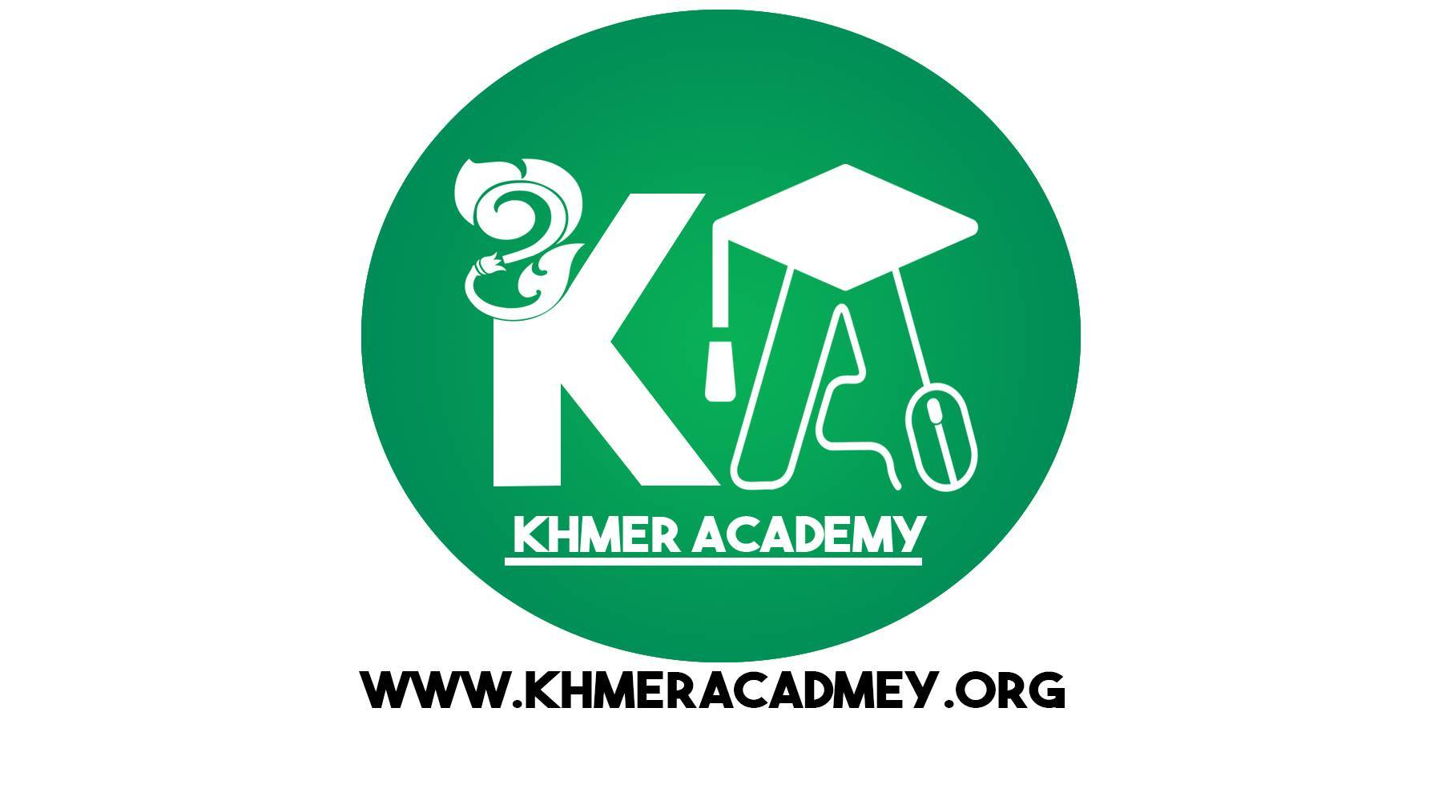**-Mindset 1:** This part is used to show meaningful word for “Academy”. Thus, we have chosen a scholar hat associated with the top of the letter "a" to show the meaning knowledge.

**-Mindset 2**: Khmer Academy is site as a source of information, knowledge, various documents for almost all levels. It is the source for a major study lessons and tips for all learners. It provides e-learning for all learners to research via electronics devices like smart phones, computers, tablet…etc., so we designed a picture of mouse associated to the design of the letter "a" instead of using just the letter "a" because a picture of mouse shows widely to the meaning of information technology, working, studying and also researching.

At the end, we merged the merged the part “K” and “A” together, then we got a fully logo like the picture below: